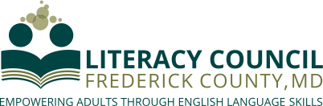
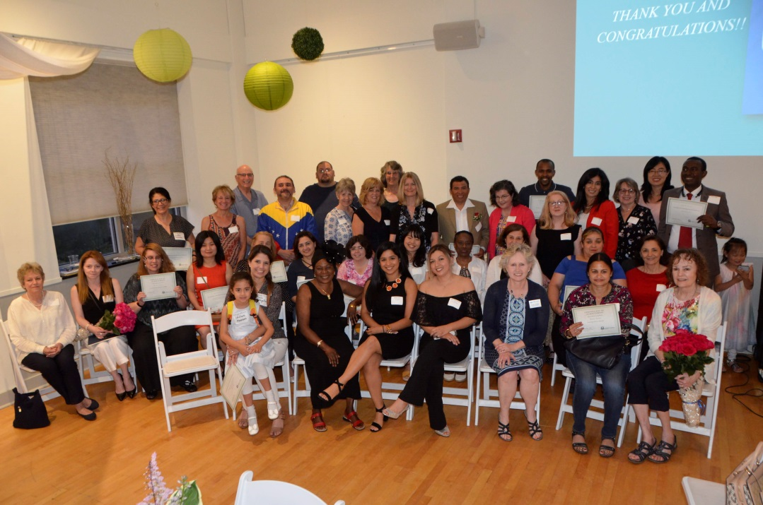

7th Annual Celebration of Achievements
June 2020 (date & location – pending)
We invite your business to consider one of the following sponsorship levels for the Literacy Council’s annual Celebration of Achievements. Your financial support will help us to recognize the accomplishments of our students, dedication of our volunteers, as well as to fund current programs and allow our organization to grow and better serve our community.

Your business will receive publicity as a sponsor before, during, and after the event. Sponsorships at all levels will include our Basic Benefits:
- Your name in the Celebration of Achievements program
- Your name and business information in the slide show played throughout the event
- Acknowledgement from the master of ceremonies at the event
- Acknowledgement in the Literacy Council’s newsletter social media posts
- Acknowledgement on the large poster displayed at the Literacy Council’s entrance and at the event
- Acknowledgement on the Literacy Council’s website for a full year

Sponsorship Levels

Community Builder Level ($1,000 or more) Basic Benefits plus:
- Your name and logo on the event signage
- A full-page ad in the event program
- Social media presence before and after event
- Logo and a link to your website on the Literacy Council’s website for a full year.
- Membership in the annual Dolly Engle Giving Society (for businesses)
Your $1,000 donation supports Workplace Literacy classes for workers in local hospitality, cleaning and restaurant sectors.

Educator Level ($500) Basic Benefits plus:
- Your name and logo on the event signage
- A half-page ad in the event program
- Social media presence before and after event
- Logo on the Literacy Council’s website for a full year.
- Membership in the annual Dolly Engle Giving Society (for businesses)
Your $500 donation supports three Tutor Training workshops.

Sustainer Level ($250) Basic Benefits plus:
- A one-fourth-page ad in the event program
Your $250 donation provides workbooks and teaching materials for five adult learners.

For more information, please contact our Executive Director, Laurie Fisher, at (301) 600-2066 or lauriefisher@frederickliteracy.org.
Thank you for your support!

OUR VISION … A COMMUNITY WHERE LITERACY
IS ATTAINABLE FOR EVERYONE
