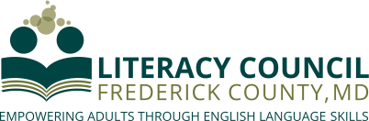

Presents
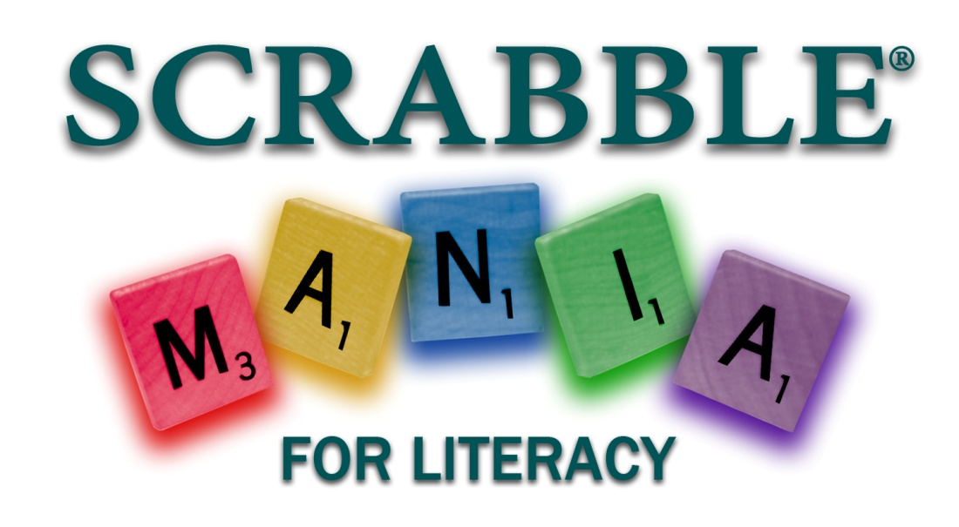
Support
SCRABBLE®MANIA for Literacy
Saturday, March 30, 2019, 2:00-5:00 p.m.
Dutch’s Daughter

We welcome sponsors at every level of the Literacy Council’s annual SCRABBLE® MANIA for Literacy. Cash and in-kind contributions will count toward any sponsorship level. Your donation will be used to raise the funds that will allow our programs to grow. Help us end illiteracy in Frederick County!

Your business will receive publicity as a sponsor before, during, and after the event. Sponsorships at all levels will include:
- Your name in the program
- Your name and business information in the slide show played throughout the event
- Thanks to you from the master of ceremonies at the event
- Thanks to you in the Literacy Council’s newsletter
- Your name on the large poster displayed at the Literacy Council’s entrance and at the event
- Thanks to you on the Literacy Council of Frederick County’s website and social media
Additional benefits at each level include:

Double Letter Sponsor ($100) All the above plus:
- 1 ticket to the event

Triple Letter Sponsor ($250) All the above plus:
- Your logo included on the program and in the slide show
- Total of 2 tickets to the event

Double Word Sponsor ($500) All the above plus:
- Listing (with your logo) as a major sponsor in our event ads in the Frederick News-Post
- Your name and logo on the participant registration packet and event signage
- A half-page ad in the event program
- Social media presence before and after event
- Special thanks and a link to your website on the Literacy Council’s website
- Recognition as a founding member in the Literacy Council’s new Giving Societies program (for individuals)
- Total of 3 tickets to the event

Triple Word Sponsor ($1,000 or more) All the above plus:
- A full-page ad in the event program
- Recognition as a founding member in the Literacy Council’s new Giving Societies program (for businesses, foundations and organizations)
- Total of 4 tickets to the event

Or, be a Team Sponsor for $220 ($190 before February 14)
- 4 tickets to the event for your employees, adults participating in literacy programs, etc.
- Your name will be listed as a Team Sponsor in the event program and slide show

For more information, please contact our Executive Director, Laurie Fisher, at 301-600-2066 or lauriefisher@frederickliteracy.org.
Thank you for your support!

SCRABBLE® is a trademark of Hasbro in the US and
Canada. ©2015 Hasbro)
All rights reserved

