Come play at
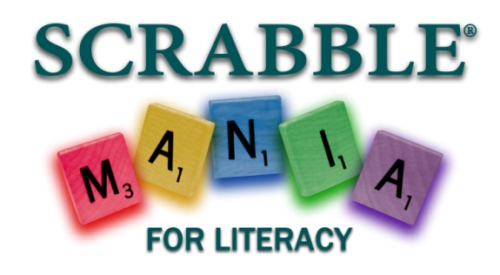
Please join us for
SCRABBLE®, hors d’oeuvres, wine*, cash bar, and silent auction at the Literacy Council’s 4th Annual SCRABBLE® MANIA for Literacy! *One complimentary glass of wine included
Come enjoy
- Seat(s) at SCRABBLE® MANIA
- Playing and competing as part of a team
- Heavy hors d’oeuvres, wine and cash bar
- Exciting items in our silent auction
- The opportunity to support adult literacy programs in our community
$220 for a team of four or $60 for individuals*
*Register by February 14, 2019 to take advantage of the Early Bird team price of $190 or individual price of $50!
Please sign me up for ______ seat(s)!
PLAYER NAMES and emails:
Player 1: ____________________________
Player 2: ____________________________
Player 3: ____________________________
Player 4: ____________________________

Saturday, March 30, 2019
2:00-5:00 pm
Dutch’s Daughter Restaurant
581 Himes Avenue, Frederick, MD

http://www.dutchsdaughter.com/directions.htm

_____I am unable to participate this year, but would like to make a contribution of $_________ to support the event.

Please send your payment to:

Literacy Council of Frederick County
110 E. Patrick Street
Frederick, MD 21701

Payment:
Please make enclosed check payable to Literacy Council of Frederick County.

NAME: ____________________________

ADDRESS: __________________________

CITY: ______________________________

ZIP: _______________________________

PHONE: ___________________________

EMAIL: ____________________________

Questions?

Contact Laurie Fisher
(301) 600-2066
or info@frederickliteracy.org

www.frederickliteracy.org

